ENE3150 Galvanic Cell Lab Galvanic Cells

In this lab, several galvanic cells (sometimes called voltaic cells) will be constructed. The experimental voltage values of each one will be measured and then compared to the theoretical values given in a Standard Reduction Potential table. Galvanic cells are electrochemical cells composed of two ionic solutions, a metal anode and cathode, and a salt bridge.

In a galvanic cell, two half-cells are used. The half-cell consists of a metal and a corresponding salt solution. Energy from the cell is produced from an oxidation-reduction reaction between the two half-cells. A salt bridge is used to keep the solutions separate but will pass anions to maintain electrical neutrality. At the two electrodes (the metal strips) is where an electron exchange can be made. This electron exchange is where the energy is available for use and can be measured by a volt meter. The voltage reading is a difference of the standard electron potentials given for each half-cell.

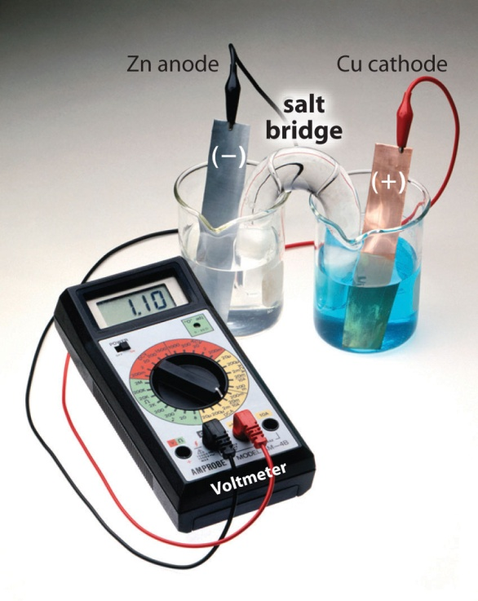
Cells to be constructed:
Cu/Cu(NO₃)₂
Pb/Pb(NO₃)_{2 460 mv}

Zn/ZnSO₄
Cu/CuSO_{4 980 mv}

Fe/Fe(NH₄)₂(SO₄)₂
Zn/Zn(NO₃)_{2 270 mv}

NOTE: All solutions EXCEPT the NaCl should be disposed of in the container labeled HAZARDOUS WASTE.
Procedure:
- Choose and begin setting up one of the cells above by pouring about 25-30mL of one solution into a 50mL beaker, and approximately 25-30mL of the other solution into another 50mL beaker. (Estimate, do not use a graduate. Beakers should be about half to two-thirds full.)
- Shine electrodes with steel wool by placing the metal on a piece of cardboard provided for that purpose and then placing them in the 50mL beaker that has the corresponding metal solution in it.
- Fill a U tube completely with the sodium chloride solution.
- Place a cotton in each end of the U tube.
- Turn the U tube upside down and place with one end in each 50mL beaker.
- Attach a volt meter to the metal strips in the 50mL beakers.
- Wait about a minute before taking the voltage reading.
- Record voltage and clean out the 50mL beakers and the U tube.
- Repeat for each of the above cells. Construct a new salt bridge for each new cell.

